Multi-channel readout electronics for silicon PIN diodes

based on SKIROC2 ASIC

MA Si-yuan (马思源)1,2, LIU Shu-bin (刘树彬)1,2*, LIU Hao(刘豪) 1,2, FANG Zi-hang(方子航)1,2, LI Cheng(李诚)1,2, FENG Chang-qing(封常青)1,2, AN Qi(安琪)1,2

*1State Key Laboratory of Particle Detection and Electronics, University of Science and Technology of China, Hefei, 230026, China*

*2Department of Modern Physics, University of Science and Technology of China, Hefei, 230026, China*

*E-mail: zlei@ustc.edu.cn*

**Abstract:**

The .

**Key words：**SKIROC2, Silicon PIN diode, Front-end electronics, Readout system, Data acquision

# Introduction

Silicon PIN diode, which is widely used in high-energy physics detectors1 2, plays an important role in photoelectric conversion. Since the future colliders, such as the International Linear Collider (ILC)3 and Circular Electron Positron Collider (CEPC)4, demand higher energy resolution of the jets, the Particle flow Algorithm (PFA) was put forward to make precise measurements of the jet’s energy5. According to the PFA, the particles inside the jets should be separated and the tracks should be assigned to the calorimeter clusters one by one, leading to a requirement for high granularity imaging calorimeter. Thanks to the fine resolution of energy and position, the silicon PIN diodes arrays is taken as the sensitive layer of silicon-tungsten-based Electromagnetic CALorimeter (Si-W ECAL), which is considered as a promising candidate for this type of application. Fig. 1 is an example of Si-W ECAL designed by CALICE collaboration for ILD6.

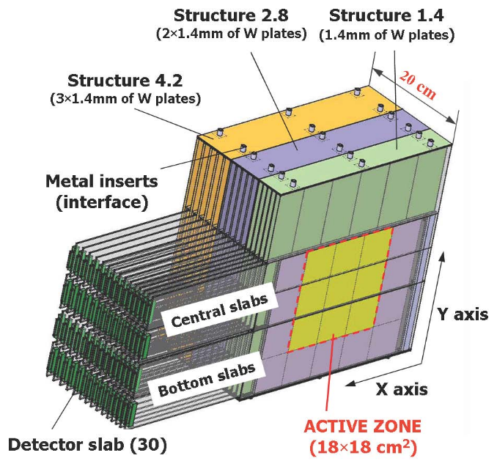

Fig. 1. 3D view of CALICE ECAL prototype 2005

The basic performance of silicon PIN diodes need to be tested before using. According to the CEPC requirements for the Si-W ECAL4, the pixel pad of silicon PIN array should be about 1 × 1 cm2, or even smaller. It should also have enough Signal-to-Noise Ratio (SNR) for Minimum Ionizing Particle (MIP). The energy range must be more than 500 MIPs. To meet these demands, the readout electronics are expected to have an equivalent noise level of better than1 fC and a linear range up to at least +2000 fC, considering the equivalent charge of MIP is about 4 fC6. In addition, the electronics are expected to be self-triggered and the threshold could be set lower than 1 MIP.

To satisfy the requirements mentioned above, a multi-channel readout electronics was developed to test the basic performance of silicon PIN diodes. This system is based on the prior work performed within the CALICE collaboration, using their ASIC and referencing to the readout electronics architecture of the CALICE ECAL physics prototype6. Details of the readout electronics and preliminary test results are presented below.

# System implement

## ASIC

## Front-end Board

## Data Interface

# Characterization

## Basic output of SKIROC2

* 1. Baseline and noise
  2. Calibration

## Trigger efficiency

* 1. X-ray test and Cosmic ray test

# Conclusions

Acknowledgments

The authors would like to thank Mr. Stephane Callier from CALICE collaboration for his help in our system design progress. We also appreciate the discussion during the design with Mr. Yunlong Zhang from University of Science and Technology of China.

This work was supported by National Natural Science Foundation of China (Grant No. 11635007).

1. S. Marrocchesi P, Adriani O, Avanzini C, et al. A silicon array for cosmic-ray composition measurements in CALET. Journal of the Physical Society of Japan, 2009, 78(Suppl. A): 181-183.
2. L. Linssen, A. Miyamoto, M. Stanitzki and H. Weerts (eds), Physics and Detectors at CLIC: CLIC Conceptual Design Report, <http://cds.cern.ch/record/1425915CERN-2012-003>.
3. T. Behnke et al., The International Linear Collider Technical Design Report - Volume 4: Detectors, [arXiv:1306.6329].
4. CEPC-SPPC Study Group, CEPC-SPPC preliminary conceptual design report: Physics and detector, Tech. Rep. IHEP-CEPC-DR-2015-01, IHEP-TH-2015-01, IHEP-EP-2015-01, 2015.
5. M.A. Thomson, Particle Flow Calorimetry and the PandoraPFA Algorithm, Nucl. Instrum. Meth. A 611 (2009) 25 [arXiv:0907.3577].
6. CALICE collaboration, J. Repond et al., Design and Electronics Commissioning of the Physics Prototype of a Si-W Electromagnetic Calorimeter for the International Linear Collider, 2008 JINST 3 P08001 [arXiv:0805.4833].